 | 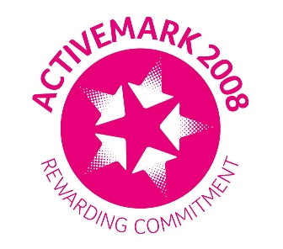 |  |  |  | 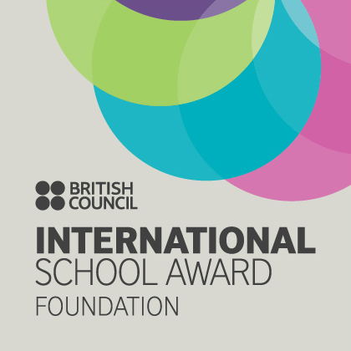

West Bretton Junior & Infant School

Newsletter

9.10.14

School Photographer

The school photographer will be paying us a visit on Thursday next week. He will be taking individual and family photographs. If any parents have younger children not yet in school who they would like to be included on a photograph, please make your way to the school hall at 9.00 a.m. next Thursday. The photographer will take these groups first so that parents are able to leave.

Playground Safety

Shortly after 3.30 p.m. last week one of our Year 1 children had a very nasty fall after colliding with another child in the playground. She suffered a bang on the head which resulted in concussion and a stay in hospital.

Now that we have so many children in school, the Foundation Stage playground is very congested at 3.30 p.m. and although it is natural for children to want to let off steam at the end of a school day, we need to do all we can to avoid accidents. For this reason we ask that parents supervise their children closely when picking them up and not allow them to chase around in the playground. Please also don`t let them use the climbing frame or climb on our neighbour`s wall. Thank you very much for your support on this.

ZooLab Visit

We had some unusual visitors in school on Tuesday when all of our full time children were visited by “ZooLab” and their collection of weird and wonderful creatures. The children were shown, and able to handle, a corn snake and a lizard amongst other things.

Sportsdesk

Our Year 5 football team are competing tonight at Horbury Academy and we wish them all – Edward Briggs, Alexander Parkinson, Isobel Walsh, Eli Lidster, Mia Stokes, Anwen Jones, Lottie Wood, Alistair Cocker, Sophie Clarke, Samuel Ollerton and Oliver Gibson – the very best of luck.

Children in KS1 and upwards have been given a flier from Slazenger Hockey Club in Horbury who are offering 3 free “taster” sessions for juniors aged between 6 and 16.

Operation Christmas Child

A letter went out earlier this week about our annual Shoebox collection. This year the boxes from this area will be sent to the Philippines. We always have wonderful support for this cause and really appreciate the time and thought which goes into the boxes. Please hand them in to the school office before Friday 7th November.

Violin lessons

Children who have violin lessons with Miss Ghent will be having their lesson on Wednesday next week instead of Thursday so please bring instruments on that day.

Golden Book

Congratulations to our “Golden Book” children this week:

Class 1 Orlaith Sagar and Joseph Heeley
Class 2 Archie Sykes and Daisy Ollerton
Class 3 Travis Joubert and Jacob O`Donnell
Class 4 Bailey Clark and Freya White

Bikeability

Would parents of year 6 children taking part in the “Bikeability” training on October 23rd and 24th please return the permission slips this week.

Year 5 children will have their training shortly after the half term break and letters will be sent out nearer the time.

Parents` Evenings

Thank you to those parents who have responded to the parents` evening letters; appointment slips will be sent out early next week. For those parents who have not yet returned them please do so by tomorrow morning as appointments will be allocated after that time.

News from Class 3

Mrs Scott is very pleased to let you know that class 3 have achieved their target for this half term which was to stay seated during lessons. They will be enjoying their reward tomorrow when they have chosen to come to school either “dressed up” or in pyjamas.

Bonfire Lunch

Kingswood, who provide our school lunches, has a special bonfire themed lunch planned for November 5th. Slips will be sent out next week, so if your child usually has a packed lunch but would like a school lunch on November 5th please look out for the slip.

On Wednesday next week there is a special “English” lunch featuring roast beef so please return the slip by Monday if you would like to order a lunch on that day.

And finally ……….

Next week is our last Art and Multisport after school club sessions, however “Glee” club will continue until the following week.

We do not expect to be affected by the possible UNISON industrial action next Wednesday and school will be open as normal.

