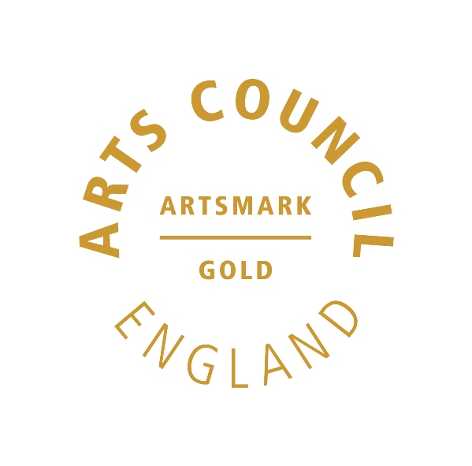 | 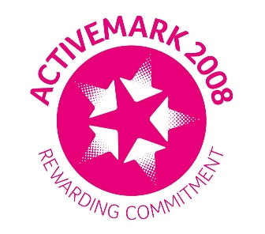 |  |  | 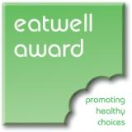 | 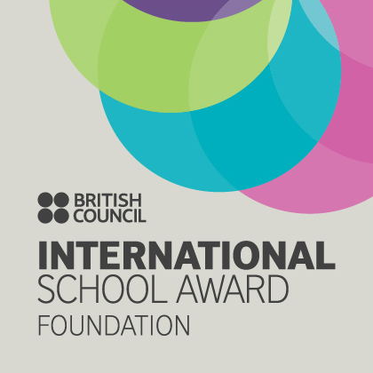

West Bretton Junior & Infant School

Newsletter
25.9.14

Harvest Festival

We look forward to seeing parents at the school Harvest Festival tomorrow afternoon at 2.30 p.m.at the Church in West Bretton. The theme for our harvest this year is “Thank you for the food we eat”. We are asking that children bring one item of their very best fruit or vegetable. After the Church Harvest Festival on Sunday morning the produce will be sold and the proceeds sent to St Catherine`s Food Bank in Wakefield, a charity which the children have chosen.

Our “Glee Club” will be singing in Church on Sunday morning and all the school community are invited to the service at 10 30 a.m.

Jeans for Genes

I am delighted to tell you that we raised £109.10 last Friday when we wore denim bottoms for “Jeans for Genes” day. Thank you very much for your support.

“Be the Best you can Be!!”

Parents will have received a letter this week regarding the launch of our “Be the Best you can Be” programme next Monday. This programme is part of the Olympic legacy and aims to inspire and encourage young people.

We are very fortunate to have David Stone, the triple Olympic champion, to speak to the children on Monday morning, and you may want to visit his website with your child before then – www.david-stone.co.uk

On Monday we would like all the children to dress up as something they would like to be when they are older, or if this is impractical, bring to school an item or picture of what they would like to be. We look forward to sharing their dreams!

School Calendar

Today we are distributing our term dates leaflet –please check your child`s bag!

Since the school calendar was printed and circulated at the end of last term, there has been a change to our INSET dates. The INSET day originally planned for 1st June has now been postponed to July 20th. The term dates leaflet is correct, however just to confirm – we now return to school after the May half term on Monday 1st June and we finish for the summer break on Friday 17th July.

Golden Book

Well done to this week`s “Golden Book” children who are:

Class 1 Martha Ollerton and Thomas Burgess
Class 2 George Godley and Melissa Fox
Class 3 Samuel Ollerton and Luke O`Donnell
Class 4 Michael Quinn and Mia Stokes

Sportsdesk

We are very proud of our cross country team after their performance last week. It was a very warm evening and some of the children had to run twice round the school field at Horbury Academy. They all tried very hard, so well done to them all - Georgina Slade, Anwen Jones, Alistair Cocker, Alexander Parkinson, Sophie Clarke, Mia Stokes, Olivia Hargill, Edward Briggs, Lottie Wood and Isobel Walsh.

