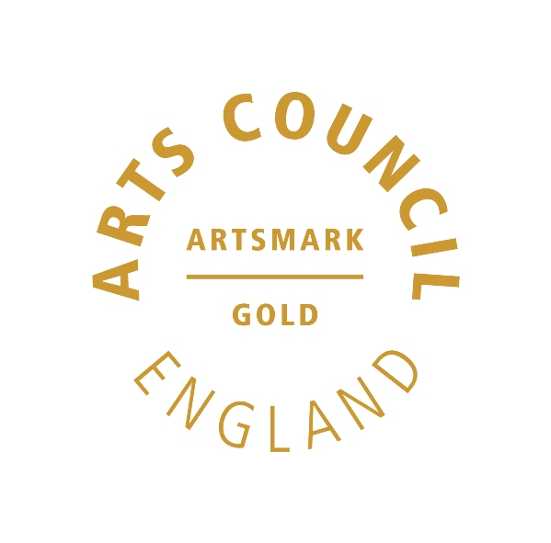 | 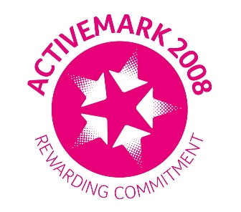 |  |  |  | 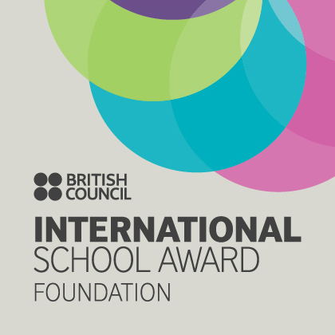

West Bretton Junior & Infant School

Newsletter
20.11.14

Children in Need

What an event! We raised an incredible £948.35!! Thank you so much for your support. The Student Council and the children`s organisation was fantastic – they made a great team. From talent show to “Bake off”, children`s stalls for bandana making, nail painting and “Find the Pudsey Paws”, culminating in a wonderful assembly – it was all brilliant. I was amazed at the talent and confidence of our pupils and I am extremely proud of them.

Finally a big “thank you” to all the staff involved – you were INCREDIBLE! The Chicken Run relay will never be forgotten! In particular special thanks to Mrs Corson and Miss Riley for assisting in putting it all together.

“Bake Off”

There were some amazing entries for our “Bake Off” last week, and it was a very difficult (but enjoyable) task for our tasters to decide on the winners.

The winners were eventually chosen as:
Foundation Stage – Evie Mills
KS1 – Gabrielle Lannon
Lower KS2 - Emily Clarke
Upper KS2 - Sam Lodge
Adults – Ms White ( Freya`s Mum!)

Congratulations to them all.

Anti-Bullying Week

The theme for this year`s anti-bullying week is “Let`s Stop Bullying For All”. Children have had assemblies and we are doing classwork on what bullying is, why bullies bully, what to do if you are being bullied and how we can stop bullying. Our Student Council have decided that in support of anti-bullying week children should wear blue tomorrow to remind people that we want to stop bullying for all.

Golden Book

Congratulations to our “Golden Book” children this week who are:

Class 1 Leo Wood and Isabella Barber
Class 2 Sophie Fisher and Albie Robertshaw
Class 3 Lucy Fisher and Esther Atkinson
Class 4 Olivia Hargill and Sam Lodge

Maths Information Evening

Thank you for your support of our Maths Evening for parents yesterday which we hope that you found useful. For any parents unable to join us, there are booklets available from the school office.

Sportsdesk

Our Year 6 basketball team competed at Horbury Academy last Thursday. Despite a number of unlucky shots, they still managed to take 3rd place. They played extremely well together – well done Dylan Driver, Alistair Cocker, Alexander Parkinson, Edward Briggs, Mia Stokes, Lottie Wood, Anwen Jones, Oliver England and Sam Lodge.

Christmas Sparkle Day

As mentioned in last week`s newsletter, we invite parents and carers to join us in school next Friday afternoon, 28th November from 1.15 p.m. for our annual “Christmas Sparkle Day”. The school gate will be opened shortly before 1.15 p.m.

Children are asked to wear clothing that is red, white, green or sparkly or a combination of all! Parents/carers please wear clothing that will be sympathetic towards glitter and glue!

Friends of Bretton School

Thank you very much to those parents who attended the FOBS AGM on Tuesday this week. It was a very productive meeting and started the organisation of the Christmas Fair and Christmas Hamper raffle.

A new treasurer, Ms Overend, was elected, and it was decided to rotate the roles of chair and secretary, starting with Mrs Costello. Many thanks to Mrs O`Donnell, Mrs Meyrick and Ms Parkin for their contributions as past treasurer, chair and secretary.

Details of the Fair are attached, however could we please ask that parents start to save their empty screwtop wine bottles, complete with cap. We would also love to hear from anyone who is a good photographer and would be willing to take the photographs of children visiting Santa in his grotto. On Monday we shall be sending out plastic cups with notes for the children to fill with sweets, small toys etc for our children`s tombola.

Class 3

Next Tuesday afternoon years 3 and 4 will be visiting St Peter`s Church in Woolley as part of their “Places of Worship” study. Please return permission forms if you have not already done so.

Several parents have kindly offered to help with transport. If your child is under 135 cm tall he/she must have a car seat. Please bring the car seat to the office on Tuesday morning and collect it Tuesday evening. If you do not have a car seat, please let us know.

Youth Sport Trust

We have been working hard to make our PE lessons exciting, varied and of a very high quality. This ensures children make good progress and enjoy PE and sport. We are also in the process of making sure that school and packed lunches are healthy. In recognition of this we have been awarded the Silver quality mark from the Youth Sports Trust.

And finally ………………
If any children in this year`s Year 5 are wishing to join the “Robinwood” visit in September next year, deposits need to be in by tomorrow.

