 |  |  |  |  | 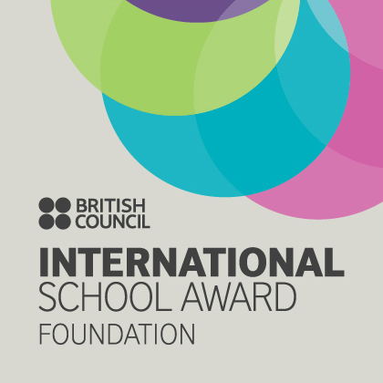

West Bretton Junior & Infant School

Newsletter
16.10.14

The Tempest

Our year 5 and 6 children worked up a storm on Tuesday evening when they performed “The Tempest” at Wakefield Theatre Royal as part of the Shakespeare School`s Festival.

All their hard work in rehearsing paid off - they were absolutely magnificent and we are so proud of them. The audience loved them and really responded to their performance. Thank you to them all and also to Mrs Sellens and Miss Riley who have put a lot of effort into this performance over the half term.

Golden Book

Congratulations to our “Golden Book” children this week:

Class 1 Myla O`Neill and Rose Guilford-Collis
Class 2 Eden Lidster and Mia Underwood-Varley
Class 3 Meredith Meyrick and Daniel Barclay
Class 4 All year 5 and 6

School Photographs

The photographer visited school this morning and took individual and family group photographs of the children. As soon as the proofs are available they will be sent to parents.

Operation Christmas Child

If anyone is struggling to find a shoebox for our “Shoebox Appeal” we have some ready printed boxes kindly donated by Mrs Ollerton. If you would like one please call into the school office.

We would appreciate boxes being brought into school by Thursday November 6th so that they can be sent on the next leg of their journey to the Philippines.

Sportsdesk

Our children from years 4,5 and 6 did wonderfully at the football tournament last Thursday when they won every match up until the final when they lost to Netherton. Well done to you all - Edward Briggs, Alexander Parkinson, Isobel Walsh, Eli Lidster, Mia Stokes, Anwen Jones, Lottie Wood, Alistair Cocker, Sophie Clarke, Samuel Ollerton and Oliver Gibson.

Our KS1 benchball team are competing at Horbury after school this evening so good luck to Sofia Degnan, Sophie Hoyland, Archie Sykes, Jimmie Lunn, James Gibson and Ella Johnson.

School Website

We are pleased to inform you that our new school website has been launched. This contains class, curriculum and performance information as well as generic information about our school. Please log on to www.westbretton.wakefield.sch.uk. There are some wonderful photos of the children in action.

Bikeability

On Thursday and Friday next week Year 6 will be having their “Bikeability” training from Wakefield Road Safety Team. Some of the children have still not returned their permission slips so please do so this week.

Year 5 will be having their training on November 10th and 11th. Their permission slips have been sent out this week, so again please return them as soon as you can.

Parents` Evenings

We look forward to seeing parents at our parents` evenings on Tuesday and Thursday next week – appointment slips were sent out with the children on Monday.

To help staff keep to their schedule we shall be having assistance from some of our older children who will act as “monitors”, and we would appreciate it if parents would help by keeping their discussion within the allotted 10 minutes. Thank you.

KS1 Assembly

Mrs Corson`s class will be having their parent assembly on Friday next week, 24th October shortly after 9.00 a.m.

Although this will be of most interest to parents with children in Class 2, we welcome all parents and carers to join us in this assembly.

After School Clubs

As we mentioned last week, the Multisports and Art clubs will finish this week for the half term. Our “Glee” club will run as usual next week.

And finally ………….

We close at the usual time of 3.30 p.m. next Friday as we begin our half term holiday. School will be closed to pupils on Monday 3rd November for a staff INSET day, reopening on Tuesday November 4th.

