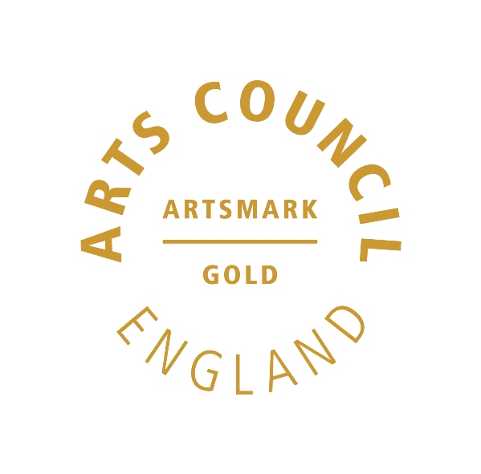 | 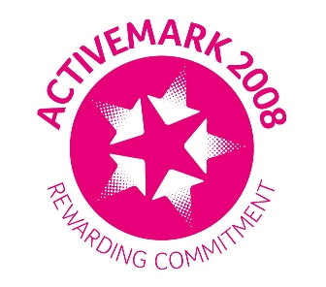 |  |  |  | 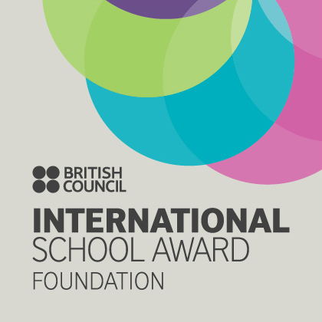

West Bretton Junior & Infant School

Newsletter
13.11.14

Children in Need

The Student Council have been busy organising Children in Need and the “Best Assembly Ever” to show what we have done for Children in Need. Last week we were notified that we were one of 48 lucky schools throughout the country to receive a box full of goodies to assist us with planning Children in Need in school. Sure enough, a few days later a gigantic box arrived full of goodies. The children were delighted.

Today we have the Bake Off and the lucky winners will be announced in our assembly tomorrow. The cakes and buns look magnificent and our team of judges are looking forward to sampling them this afternoon! Well done to our bakers!

Tomorrows events: Children are invited to come as Superheroes (the theme of this year`s Children in Need), and pay £1 for the privilege. During the day buns, drinks and fruit kebabs will be on sale at break times. Prices range from 10p a drink, 30/50p a bun/biscuit and 50p for a fruit kebab. There will also be various games including “Guess the name of the bear”, “Pin the bandana on Pudsey” and nail painting – all costing from 30 -50p. Finally, the staff have been given a challenge and will complete if IF they get sponsors! Sponsor forms have been sent out. The challenge is “The Chicken Run Trim Trail Relay”!! This involves wearing a chicken suit and doing parts of the trim trail! In addition to this all staff will be dressed up.

Our Children in Need events seem to have attracted a lot of attention. So far the Barnsley Chronicle are wanting us to send them a photograph, the Wakefield Express are coming to film our assembly and BBC Look North are coming to film the Chicken Run Relay! Surely wearing a chicken suit on National TV is worthy of sponsorship!

You are all invited to come and watch our Best Assembly Ever on Friday afternoon. The gates will open at 2.20 p.m. for a prompt start at 2.30 p.m. The assembly will consist of the winners of our talent show performing, film clips of the talent show, the Chicken Run and the Bake Off together with a presentation by Student Council. Glee Club will also be singing. Afterwards we shall be selling drinks and cakes from the Bake Off and the children will be selling their art and craft work related to Children in Need. We would be most grateful of any extra cakes, buns etc to sell throughout the day and after the assembly. Please bring these to the office tomorrow morning.

We have discussed with the children where the money goes and our target this year is to beat the previous year`s target of £333.68. Please help us to raise as much money as possible to help other children. Thank you.

Maths Evening

On Wednesday evening next week, 19th November, we shall be holding a Maths information evening for all parents. This will show how we teach the 4 rules from Foundation Stage to Year 6 and will include the changes due to the new curriculum. Parents will also be given an information booklet so that they can help their child/children at home.

Glee Club

Our Glee Club are taking part in a performance at Unity Hall in Wakefield on December 6th. We are very lucky to have been asked to accompany professional singer Rebecca Whitlam on stage. Rebecca came in to school on Tuesday to teach Glee Club the songs and will be coming back in the next few weeks to do further work with the group.

The children enjoyed singing with her and are very enthusiastic and excited at the prospect of singing in the show. Glee Club members wanting to take part need to return their permission slips as soon as possible.

This is a fantastic opportunity for the Glee Club. The concert is to raise money for “To the Moon and Back” for Austin Atkinson, plus some of the money from ticket sales will go to school. If you would like to support Glee Club in their efforts to raise funds for both causes, please see Miss Riley or Mrs Grindle for details of how to purchase tickets.

Friends of Bretton School

FOBS are holding their AGM on Tuesday next week at 7.30 p.m. here in school. At the meeting they will be electing new officers; there are vacancies for Chair, Secretary and Treasurer. They will also be organising the Christmas Fair. It would be lovely to have representatives from each class to assist with this. Please come so that responsibilities can be shared out. FOBS raised over £5000 last year which helps the school greatly, plus both children and adults enjoy their events. At present a lot of the jobs are shared between only a few people and this isn`t viable. Please support us on the 18th – it would be a great shame if FOBS were to fold.

Shoebox Appeal

Thank you so much for the shoeboxes which were brought to school for our annual “Shoebox Appeal”. This year we had a wonderful 61 boxes collected from school and the community and these were taken yesterday to start their long journey to the Philipppines.

After School Clubs

Children very much enjoyed the first of our lively “Fun Fitness” sessions which ran on Tuesday evening. All children who applied have a place for the full 5 sessions, and there are still places available if any other children would like to join. The class is free as we have used our Sainsbury`s vouchers to fund the sessions. Please complete the permission slip previously circulated if your child would like to come.

There are also vacancies for our Multisports Club which starts tomorrow.

Robinwood 2015

We are very pleased to have been able to arrange for our present Year 5 children to join Netherton school in September next year for a weekend at “Robinwood” activity centre in Todmorden. Slips asking for deposits have been sent to the children this week, so please return them by the end of next week so that we have a definite idea of numbers.

Bikeability

Our Year 5 children had their “Bikeability” training this week which they thoroughly enjoyed. The trainers particularly mentioned how well behaved and confident the children were and how much they liked coming in to our school. We are hoping to arrange for them to return in the Spring to work with years 3 and 4.

Anti-bullying Week

Next week is anti-bullying week, and Student Council will be sending out a letter on Monday to let you know what we shall be doing throughout the rest of the week.

Christmas Sparkle Day

We shall shortly let you have more details of our Christmas Sparkle Day, however you may wish to make a note in your diary that we invite parents to join us during the afternoon from 1.15 p.m.on Friday 28th November to work with your children.

And finally ……………

Mrs Sellens would be very grateful of any oddments of white wool which you do not need.

Would children in Years 3 and 4 please return permission slips for the visit to St Peters, Woolley next Wednesday. We would also be very grateful if parents of children in this class could help with transport.

