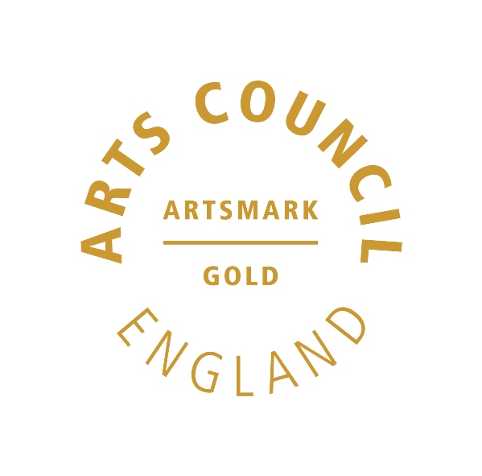 | 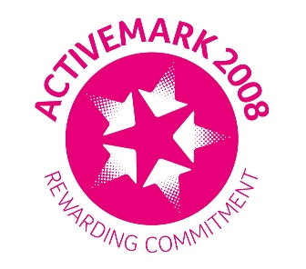 |  |  |  | 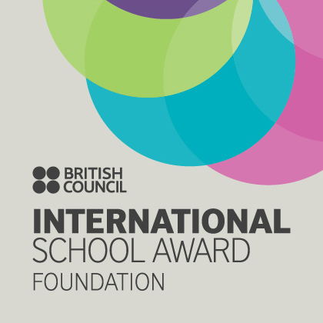

West Bretton Junior & Infant School

Newsletter
9.4.14

No, it`s not Thursday already, however we may have some technical disruption in school tomorrow so the newsletter is coming out a day early.

We are having WiFi fitted throughout school over the holidays as well as upgrading all our computers. In addition to this we have purchased more Ipads and had staff training on App “smashing” ( where different Apps are combined to make a presentation) and computer “coding” ( simple programming). Watch this space after half term!

FOBS Easter Activities

There are a few tickets left for this Friday`s Easter Disco which FOBS have arranged. It runs from 6.00 – 8.30 p.m. and will be held in the village hall. There is an Easter Bonnet competition, tuck shop, refreshments and the bar is open for parents.

Order forms are in the parent information points and should be returned as soon as possible via the FOBS post box.

Tickets are on sale at 20p each all this week for the Easter Egg raffle. Our Student Council are in charge of sales!

Africa Visit

It is with regret that I have to advise you that it was decided at the Governing Body meeting recently that the proposed visit to Africa next year will not now take place.

The aims of the project were as follows:

- To develop links with the Malealea community which would give all children in school a greater insight into life beyond Wakefield.
- To help the school community of Malealea in a worthwhile project.
- To enable our children to have an experience of a lifetime, assisting another community.

Unfortunately, as more individuals have withdrawn from the project, the final point has resulted in only a few children actually taking part in the expedition.

The governors believe that we can still continue developing our link and assisting with the Malealea community, however due to the small number of children still involved, they feel that the visit should not now take place.

Thank you for your commitment and support of the project so far. Any funds that we have raised will go to the Malealea community. We will still be looking at Lesotho in our topics and making further links with the school.

Lunch Money

We have a very short half term after Easter, and lunch money will be £34.20 for the full period. This takes into account the May Day holiday on May 5th. Please make all payments, either weekly or half termly, promptly on our first day back after the break.

Parents` Evenings

Thank you for your support of our parents` evenings yesterday and this evening. We hope that you will find them informative.

Thank you too to our monitors for helping the evenings to run smoothly.

After School Clubs

As we advised last week, our Multiskills after school club has finished for this half term. We hope to distribute fliers for the next sessions in our first week back.

Lesotho Bags

In February we had a printmaking artist working alongside all our KS2 children. They learnt different print making techniques and both designed and made some fantastic tote bags. If you would like to purchase your child`s bag a contribution of £5 would be appreciated. This includes the cost of the bag and the printing inks. Please ask your child about them.

And finally …………

We finish for the Easter holiday on Friday at 3.30 p.m. We hope that everyone has a lovely break and we look forward to seeing the children back in school on Monday 28th April. Please remember that the Monday of the following week, May 5th is the Bank Holiday and school is of course closed.

