 | 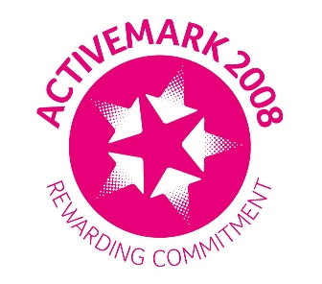 |  |  |  | 

West Bretton Junior & Infant School

Newsletter

8.5.14

We have another new starter this week as Eleanor Leighton joins us in Mrs Firth`s class. We are very pleased to have her with us, and give her a big welcome.

Parking

Unfortunately it is necessary to remind parents once more of how important it is that everyone is mindful of our children`s safety when parking.

Several of our parents have reported that cars are double parking on Bretton Lane, and even parking on the pavement. As we increase the number of children in school it is inevitable that there may be some overspill from the village hall car park, but there is no excuse for putting lives at risk by parking on the pavement. Please be sensible when parking – even if you think that you may only be a very short time.

School Admissions

If any of our parents with children in Lower Foundation Stage have not yet returned the slip to the local authority admissions department this must be done by tomorrow at the latest.

Foundation Stage News

We are hoping for a fine afternoon tomorrow when our Foundation Stage full time children are walking to the YSP. Parents – please remember to collect from the car park reached via Park Lane at 3.15 p.m.

On June 5th the whole of Mrs Firth`s class will visit Tropical World in Leeds. Permission slips have been sent out this week so please return them as soon as possible.

SATs

As we told parents in last week`s newsletter, we are very busy at the moment with various tests – not least the KS2 tests which will take place next week. Please ensure that children are in bed in plenty of time and have a good breakfast so they are well prepared for their day.

Cricket Session

West Bretton Cricket Club are running an after school “taster” session for years 2,3 and 4 on Wednesday next week from 3.30 – 4.30 p.m. Places are limited to 15, so would parents of interested children please return the slips by tomorrow.

Headlice

We have recently had a case of head lice in school, so please check your child`s hair and treat as necessary.
FOBS Summer Fun Day

Hopefully the very popular FOBS Summer Fun Day on the evening of 11th July will go ahead. However, the committee of FOBS is currently very small, and the members are unable to organise and run events without help from other families.

On Wednesday 21st May we are holding a meeting for any parents/grandparents who are willing to help out, even on an occasional basis, and particularly with the Summer Fun Day. The meeting will be in school at 3.30 p.m. and a crèche will be available for the duration of the meeting.

Please put the date in your diary and come along to the meeting – it would be a great shame if Friends of Bretton School were to cease. The group has been in existence for a lot of years and has raised thousands of pounds for “extras” for our children.

And finally …………..

The FOBS Easter Egg raffle raised £98.10 – thank you to all who bought tickets.

Our weekly “Celebration Assembly” is to be held tomorrow instead of today, so there are no “Golden Book” children to mention as yet. We will put two weeks` names in next week`s newsletter.

