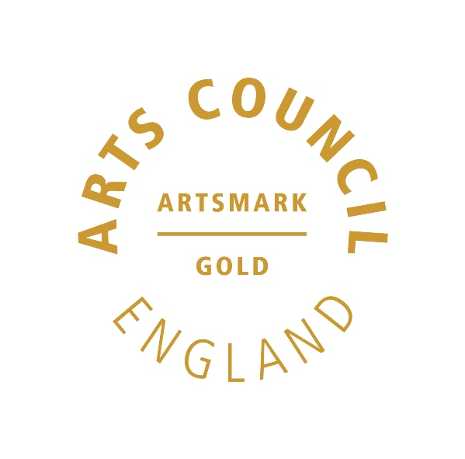 | 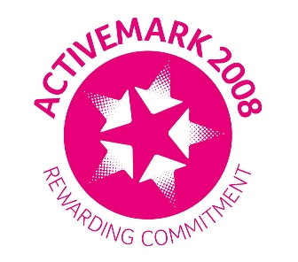 |  |  |  | 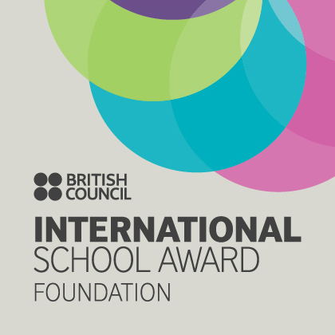

West Bretton Junior & Infant School

Newsletter

6.3.14

World Book Day

Today we celebrated World Book Day and it has been great to see the children in their book character costumes.

During the day the children have been put into four groups of mixed ages and moved round school looking at a different book by author Roald Dahl. Our James and the Giant Peach group have been making insects, a giant peach collage and a peach delight. As expected, the Charlie and the Chocolate Factory group have made a sweet machine, chocolates with “Golden Tickets” and chocolate lollies! The Twits group made “disgusting food” (the children`s words!) with pretend worms. They made germ pictures and a collage of the Roly-Poly Bird. The Witches group were busy making bat silhouettes, pop up witches and broomstick bookmarks.

The older children have been absolutely fantastic with helping the younger ones, and everyone has very much enjoyed the activities. Special thanks too to the staff as the day has taken a lot of planning and shopping for resources.

Earlier this week all children were given a £1 book voucher. You will know that we are holding our Book Fair after school from Tuesday to Friday next week, and the vouchers can be redeemed either then, or at a participating bookseller before 30th March.

Blue Planet Visit

Our Year 5 and 6 children`s current topic is “Water, Water Everywhere” and they had a fascinating outing connected to this last Friday when they visited Blue Planet Aquarium in Chester.

They spent time looking at the various tanks and enjoyed a workshop on crustaceans and other sea creatures. They saw the otters being fed, and the highlight of the day was the session when the rays and fish are fed by divers!

Africa Fundraising

Tomorrow during morning break Ms Trueman, Edward Briggs` Mum will be selling toast to raise money for the visit to Africa next year. The toast will be 30p a slice and on sale from the school kitchen by the library.

Our box for the shoe collection is in place by the hall entrance in the KS2 corridor. Please bring in paired shoes for our collection as reported last week.

Sportsdesk

On Tuesday next week we have a Year 6 Netball Festival for which we have been very busy practising. Watch this space next week for results.

Eureka!

Letters have been distributed to our Year 3 and 4 children this week regarding a visit to Eureka! Children`s museum in Halifax. If it hasn`t reached you yet, please search bags and return the slip as soon as possible. Thank you.

And finally …………..

Due to our World Book Day today we have not had our usual “Well Done” assembly. This will instead be held tomorrow morning, so next week we will have two lots of “Golden Book” children to congratulate.

