 | 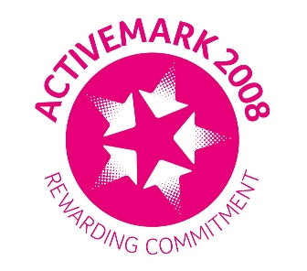 |  |  |  | 

West Bretton Junior & Infant School

Newsletter
5.6.14

Welcome back everyone – we hope that you enjoyed the break despite the disappointing weather.

Educational Visits

Our Foundation Stage children set off very excitedly this morning on their visit to Tropical World in Leeds. Luckily the weather has held so far so they will be able to enjoy their lunch and let off steam in neaby Roundhay Park.

On Wednesday next week our KS2 children are travelling to the Yorkshire Showground in Harrogate to a special school`s Countryside Day. This is always a very busy and interesting day as the children move between demonstrations of sheep shearing, sheep dog exhibitions, pond dipping, dry stone walling, crafts, food tasting etc. – we have difficulty fitting everything in to one day.

Just as a reminder for parents – we leave school at 8.30 a.m. so please make sure children are here promptly as we cannot hold up the coach for latecomers. We will be back in school at approximately 4.30 p.m. Children should wear school tops and may wear comfortable and practical “bottoms”. They also require suitable outdoor clothing for the weather, strong shoes (not sandals) and a packed lunch and drink.

After School Clubs

Our very popular “Chic Charity Club” got off to a flying start yesterday after school. Around 20 children attended, and each has been delegated a job. The theme of the fashion show is to be “HawaianTropical” and already the children are choosing which outfits will go together.

There is no club next Wednesday due to the number of children away from school on the Harrogate visit.

We shall be sending out fliers in the next day or so for our usual after school Multisports club which will start next Friday, 13th June. It will run for 5 sessions.

Head lice

We have had several cases of head lice in school recently so please check your child`s hair and treat accordingly.

Sainsbury`s vouchers

Thank you very much to everyone who has supported our collection of Sainsbury`s vouchers over the last weeks. Again, we have also had extra support from the village community, for which we are very grateful. We are now starting the big “count up” ready to place our order for sports equipment, so would appreciate you checking pockets, purses etc. for any vouchers still at home.

George`s Marvellous Medicine

There is a poster in the notice board by the school gate advertising an outdoor performance of Roald Dahl`s “George`s Marvellous Medicine” which is to be held on Woolley Village Recreation Ground on Friday 4th July. All proceeds are for Wakefield Hospice, and details of how to obtain tickets are on the poster.

And finally ………..

Attached is our “Diary Dates” list.

