 | 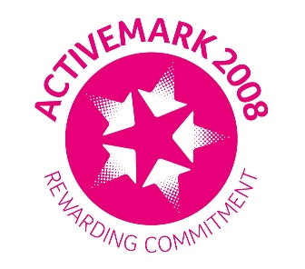 |  |  |  | 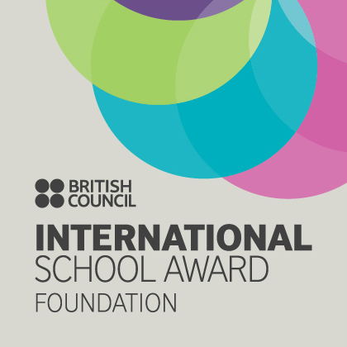

West Bretton Junior & Infant School

Newsletter
3.7.14

Grand Depart Day

We are celebrating our Grand Depart Day today, and as requested the children have dressed in yellow as a fundraiser for the Yorkshire Air Ambulance.

We have had a “flying” visit from the Yorkshire Air Ambulance mascot – a large yellow helicopter - which gave the children much amusement over their lunch. Many thanks to parents for supporting this event - we hope to let you know next week how much we have raised.

Sportsdesk

Our kwik cricket team did very well last Thursday when they competed in the West Yorkshire finals. Even though they didn`t get to the grand final they played extremely well as a team. They were wonderful ambassadors for our school and we are very proud of them. They had a great day and were rewarded for their efforts with a souvenir shirt and cap.

We had success at the swimming gala at Ossett on Friday when we came a very close second being only 2 points behind the winners. Again very well done to those involved. For a small school we do amazingly well at our sporting events.

Golden Book

Congratulations to our “Golden Book” children this week:

Class 1 Tilly Davitt and George Godley
Class 2 Emily Clarke and Jimmie Lunn
Class 3 Georgina Slade and Bailey Clark
Lass 4 George Booth and Sam Lodge

Open Afternoon

We hope that parents and friends will join us on Monday afternoon next week from 2.30 p.m. when the children look forward to showing you their work. The school gates will be opened at 2.30 p.m. – please go directly to your child`s classroom.

Immediately after the open session we are holding our charity fashion show, details of which were sent out last Friday. The children will be modelling clothing donated by Marks and Spencer which will then be available to buy. There are refreshments on a “tropical” theme, and we are very grateful to Blacker Hall Farm Shop who are donating the fruit. Please return your ticket requests as soon as possible.

Strike Action

Parents will be aware from the press that there will be disruption in schools on Thursday next week, when the NUT and UNISON have called for strike action by their members.

Our Foundation Stage and years 3,4,5 and 6 will be open as usual on that day and school lunches will be provided as normal. Years 1 and 2 will not be open.

FOBS Family Fun Night

Please continue to order your tickets for the Family Fun Night on Friday next week, 11th July. Please put envelopes in the FOBS post box outside the school office door.

FOBS would be very grateful of buns, cakes etc to sell at the Family Fun Night – please leave them in the school office next Friday. If anyone else is willing to volunteer to help during the evening it would be much appreciated – even if only for half an hour to help with refreshments etc. Please see a member of FOBS or leave a message with Mrs Brearton or Mrs Baker in the office and we will pass this on.

And finally ……….

Our violinists will have their last session for this term on Thursday next week when they will be showing the rest of our children how well they can play!

