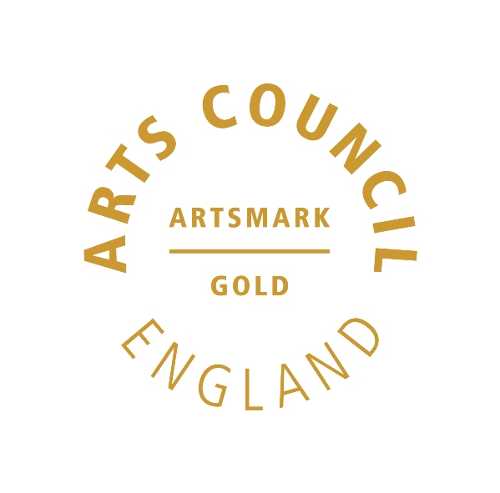 | 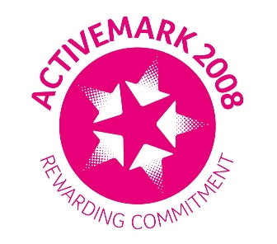 |  |  |  | 

West Bretton Junior & Infant School

Newsletter

3.4.14

FOBS

There is still time to order your tickets for the FOBS Easter Disco to be held on Friday next week from 6.00 – 8.30 p.m. at the village hall. There are order forms in the parent information points – please return them with payment to the FOBS post box outside the school office.

As part of the evening there will be an Easter Bonnet competition. This can be any form of headgear as long as it is made by the wearer!

During Friday next week the children will be making Easter nests, Easter bunny biscuits etc to sell at the disco. From Monday there will be raffle tickets on sale for 20p each for the FOBS Easter egg raffle. This will be drawn in school on Friday. Tickets will be on sale every day next week.

FOBS are currently quite a small group of parents who do a wonderful job of organising and running various events throughout the year. They would love to welcome new members to help share the load – please speak to one of the committee if you are able to join the group.

Glee Club

The Church in West Bretton has asked that we give a huge “thank you” to children and parents who supported the Mothers` Day service on Sunday. The children were absolutely fantastic – not only their singing (which brought a tear to many an eye!) but also their behaviour, confidence, and the help they gave in distributing the daffodil bouquets. So a special mention this week to Alexander Parkinson, Melissa Fox, Mia Underwood-Varley, Sol Wood, Isobel Walsh, Esther Atkinson, Anwen Jones and Sofia Degnan.

A big “thank you” to Miss Riley for rehearsing and directing them so well.

Parents Evenings

Appointment slips were sent out on Tuesday for our parent evenings next week. Please check children`s bags if yours hasn`t yet reached you.

Golden Book

Well done to this week`s “Golden Book” children:

Class 1 Matthew Drury and Myla O`Neill
Class 2 Sofia Degnan and Frankie Jones
Class 3 Ellie Marshall and Alexander Parkinson
Class 4 Edward Briggs and Olivia Hargill

After School Club

Tonight is the last session for this term`s Multisports Club – there is no club next week. Fliers will be sent out after the Easter break regarding any after school club(s) next term.

Community Lunch

We look forward to welcoming members of the community next Thursday when they will be joining the children for lunch. Afterwards our violin group and Glee Club will provide the entertainment. We are always pleased to hear how much these occasions are enjoyed by the visitors– we certainly enjoy having them!

And finally ………..

Children will not need reminding that we finish at the usual time of 3.30 p.m. next Friday for the Easter holiday. We return to school on Monday 28th April. If you are planning any excursions over the holidays please check in the corridors as there are several vouchers for SeaLife Centre, Legoland etc which may be of interest.

