 | 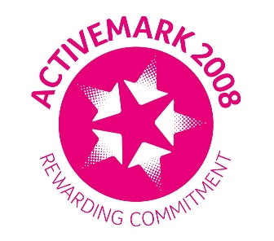 |  |  |  | 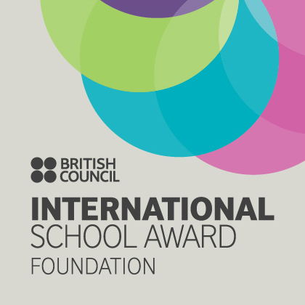

West Bretton Junior & Infant School

Newsletter
26.6.14

Sports Day

Thank you to all those parents and friends who turned up to support our Sports Day yesterday. We were very lucky with the weather and the children were very competitive and sportsmanlike!

We hope that you will join us in school again on Monday 7th July from 2.30 p.m. when we shall be holding our Open Afternoon. The children look forward to showing you their work. At 3.30 p.m. that day the children will be holding a fashion show and sale of M & S clothes – full details will be sent in the next day or so. The cost is £3 adult and £1.50 for children and includes fruit kebabs and a drink

FOBS Fun Night

Together with this newsletter is a ticket order form for the FOBS Fun Night to be held on Friday 11th July. Please order your tickets as soon as possible and put requests in the FOBS post box by the office door.

We are grateful to the people who have offered assistance to enable the event to go ahead. FOBS are short of committee members and would really appreciate new support. In particular they will be requiring a treasurer as from September. Please consider becoming a member of FOBS – it`s a great way to meet other parents whilst doing something really worthwhile for the school.

Pyramid Music Day

A group of our children, accompanied by Mrs Grindle and Miss Riley, had the opportunity last Friday to take part in a pyramid music day at Horbury Academy. During the morning they were either part of the choir, where they learnt 3 songs, or in the orchestra, learning 2 songs. Later in the afternoon all the children showcased their production to parents – they did wonderfully and Mrs Grindle and Miss Riley especially asked that we say how proud they were of our school. Thank you to parents for their support in getting children to Horbury and attending the performance.

Golden Book

Congratulations to our “Golden Book children this week:

Class 1 Sophie Fisher and Ruby Garthwaite
Class 2 Wilf Stokes and Mia Underwood-Varley
Class 3 Isobel Walsh
Class 4 Dylan Driver, Olivia Hargill and Amelia Jones.

Free School Meals for FS/Y1

Would parents of children who will be in Reception or Year 1 next year please reply to the slip regarding the provision of a free school meal if they have not already done so.

Non Uniform Day

Next Thursday we are celebrating the “Grand Depart” in school and we shall be having a non uniform day when we ask that children wear yellow. We are hoping that each child will make a donation of £1. One of our parents has reason to be very grateful to the Yorkshire Air Ambulance Service and proceeds from our day will be sent to this charity.

Sportsdesk

Our year 5 / 6 cricket team – Harry Wormstone, Andrew McWilliams, Alistair Cocker, George Booth, Sam Lodge, Edward Briggs, Emily Fuller, Oliver Williams, Lucy Care and Mia Stokes – have a big day today when they represent Wakefield in the West Yorkshire Schools Kwik Cricket competition at Hunslet Nelson Cricket Club. They have done excellently to qualify and we are sure they will have had a fantastic experience.

Tomorrow our years 5 and 6 are busy again when we have a team of swimmers competing in the swimming gala at Ossett Academy. We wish them all – Lucy Care, Steven Taylor, Lottie Wood, Emily Fuller, Andrew McWilliams, Isabelle Lidster, Alistair Cocker, Amelia Jones, Dylan Driver, Oliver Williams, Mia Stokes, Sol Wood and George Booth - the best of luck.

Last Thursday our KS1 children competed in races and relays, again at Horbury. They were a credit to our school and all tried their very best.

We must give a huge “thank you” to parents who have helped us with transport both to the cricket and to the swimming gala – we really do appreciate the support as we could not manage without it.

Bretton Family Fun Day

We have been asked to let parents know of a Family Fun Day to be held at West Bretton Cricket Club on Sunday 20th July. There is a poster in our notice board, and children will be given a flier tomorrow. There is the opportunity for children to be coached by a member of the “Pro Coach Yorkshire” team, as well as a 20/20 cricket match, Pimms bar, bouncy castle, barbecue etc. All proceeds from the event will go towards providing a Christmas Tree for our village.

And finally ………

Mrs Ollerton has asked us to let parents know that if uniform is ordered by 11th July it will be here for September. There are order forms in the parent information points – please put your orders together with payment (cheque or correct cash please) in the FOBS post box.

Would parents of our violin children note that Miss Ghent will be here on Wednesday afternoon next week instead of Thursday.

A big “thank you” to parents for supporting our request that children have their hair tied up/in plaits – we WILL get rid of the head lice!!!

