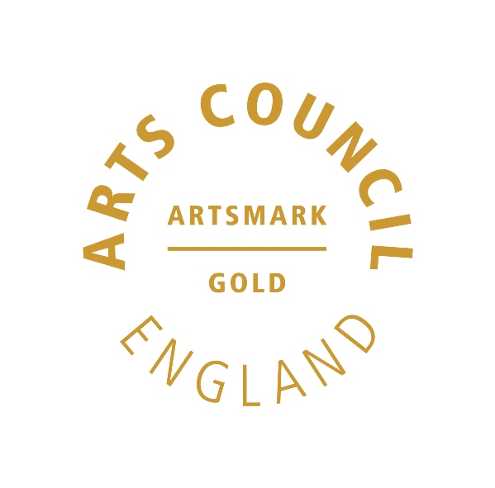 | 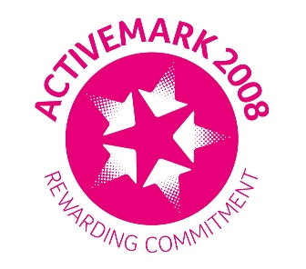 |  |  | 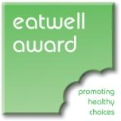 | 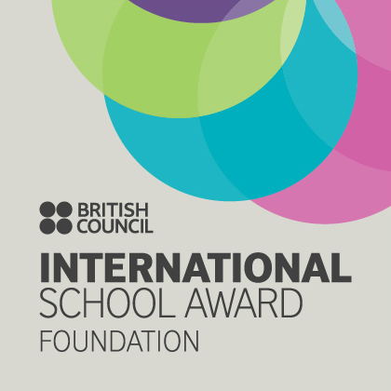

West Bretton Junior & Infant School

Newsletter

23.1.14

Student Council

Our Student Council met recently for their first meeting of this term. Their first task was to choose their “new look” badges of office!

It was down to business then, as they are playing a role in our upcoming Governor Training Day next Wednesday.

The Student Council will be giving a presentation to the Governors on part of our curriculum. They have gone away to research the topics which have been covered in classes and then feed back which have been class favourites and what activities the children would like more of.

Netball Club

Our after school netball club for years 4, 5 and 6 met for the first time yesterday. The children were very keen and enthusiastic, so thank you to Mrs Stakes and Miss Fletcher (Ms Kaye`s daughter) for giving up their time to run the club. There are two more sessions - clubs do not run on the last week of term. There are a few spaces left if anyone from years 4 – 6 is interested.

Golden Book

Well done to this week`s “Golden Book” children:

Class 1 Alfie Hall and Gabrielle Lannon
Class 2 Sophie Hoyland and Frances Cocker
Class 3 Lucy Fisher and Eli Lidster
Class 4 Freya White and Lily Walsh

Sportsdesk

Our Year 3 Benchball team - Ellie Marshall, Samuel Ollerton, Oliver Gibson, Lily Sykes, Paige Burnside, Nicholas Gladman and Amelie Gladman played well at Horbury Academy last Thursday in the pyramid competition. They showed great team working skills – well done to you all!

Our next sporting competition is on Thursday next week when we shall be entering a team in the KS1 Multiskills tournament – again at Horbury Academy.

Breakfast Club

Please have any remaining questionnaires in by tomorrow as we hope to analyse the responses next week. Thank you.

ZooLab Visitors

Our Foundation Stage and KS1 children have taken a letter home this week telling them of a visit we are having next month from “ZooLab”, a company who bring live animals/insects to schools to assist with current topics.

Foundation Stage will be learning about “Minibeasts” and Years 1 and 2 “Caring for Living Things”.
Would parents please check their children`s bags for the letter and return the attached slip as soon as possible. Thank you.

