 | 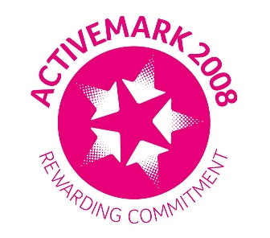 |  |  |  | 

West Bretton Junior & Infant School

Newsletter
20.3.14

Sport Relief

Following last week`s letter from our Student Council, we look forward to a good day tomorrow when we invite children to come to school dressed in sports kit and bring a donation of £1 towards Sport Relief. We shall be doing various activities during the day, both inside and out, so please make sure that children have clothing suitable for the weather.

As you will know, Student Council have several fundraising ideas, including selling buns and juice at break, and fruit kebabs later in the day. Donations of buns would be very much appreciated – please deliver to the school office in the morning. Thank you.

To clarify – the sports person/activity made from fruit and vegetables for the competition should be made at home and brought into school in the morning.

Golden Time

As our Golden Time this week will be linked to Sport Relief, children will not need toys or games tomorrow. Until further notice we find it necessary to ask that all electronic devices – phones, i pads etc – are not brought into school for Golden Time. Thank you for your co-operation in this.

Friends of Bretton School

Those families who receive their newsletters by e mail will have received a flier from FOBS regarding the Easter Disco to be held on the last day of term, 11th April, in the village hall. If anyone has printer problems, there are spare copies in the parent information points in both corridors. If you have a newsletter sent home with your child, a copy is attached today. (If you would like future newsletters etc by e mail this would be appreciated, so please let the office have an e mail address).

Tickets for the FOBS discos always sell very quickly, so please order your tickets in good time and put your requests in the designated FOBS letter box by the school office.

A reminder to those involved that there is a “mini meeting” at 6.30 p.m. next Thursday to finalise plans for the event.

Golden Book

Well done to our “Golden Book” children this week:

Class 1 Evie Carter and Isabella Barber
Class 2 Archie Sykes and Jimmie Lunn
Class 3 Travis Joubert
Class 4 Oliver Williams and Sol Wood

Strike Action

Parents will be aware that there will be disruption in schools on Wednesday next week, when the NUT has called for strike action by their members.

Our Foundation Stage and years 3,4,5 and 6 will be open as usual on that day. Mrs Scott`s visit to Eureka! in Halifax will go ahead as planned. There is a possibility that Years 1 and 2 will not be open, so please make alternative arrangements. We will confirm this as soon as we are able, probably on Monday.

Book Fair

Thank you very much to those families who supported our Book Fair. We have made £161 in commission to be spent on books for the children.

KS1 Assembly

We regret that that the parent assembly for Years 1 and 2 scheduled for 4th April has had to be postponed. We will of course advise of the new date once it is arranged.

And finally ………………..

Please check children`s bags early next week as letters will be going out regarding our Parents` Evenings being held on April 8th and 9th.

