 |  |  |  |  | 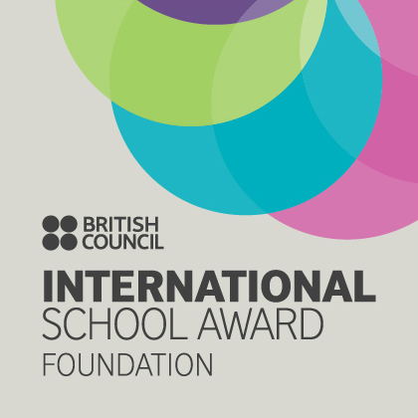

West Bretton Junior & Infant School

Newsletter

1.5.14

Welcome back everyone after our Easter break. We welcome especially Ava Costello who joins us in Mrs Firth`s class – she is already making friends and loving being here in school.

Community Lunch

Our guests from the community who joined us for lunch on the Thursday of the last week of term thoroughly enjoyed themselves. We are always very pleased to see them, and enjoyed entertaining them afterwards with music and singing. Thank you to Miss Kaye and the lunchtime staff for making it a special day, also to the members of Student Council who did such an excellent job of “meeting and greeting” our guests. Student Council also gave a presentation about their role in school which the community found extremely interesting.

Friends of Bretton School

The Easter Disco held on the last day of term was a huge success. Thank you so much to FOBS who organised the event, staff who helped on the evening, and of course to parents and children for their support. A total of £346.88 was raised.

The 100 Club for March, April and May was drawn today. Lucky winners are:
March 1st prize Kevin Jones, 2nd Mrs Firth
April 1st prize Mr M Wood 2nd Michael Murray
May 1st prize Mr J Grindle 2nd Thomas Murray

Would you please collect your prize from the school office. Thank you to everyone for their support.

Golden Book

Well done to our “Golden Book” children this week who are:

Class 1 Ava Costello and Sophie Fisher
Class 2 Ella Johnson and Madeleine Care
Class 3 Joe Hoyland and Brianna Greenwood
Class 4 Amelia Garthwaite and Andrew McWilliams

100% Attendance

At our celebration assembly today 33 children were presented with 100% attendance certificates for the Spring term – this represents almost a third of our children and is a wonderful achievement. The 33 children were put in a draw and Amelia Jones and Tom Cawthorne were presented with a WH Smith voucher.

SATs

Children from Y6 will be taking their SATs this half term during the week commencing May 12th

Year 2 children will be taking their SATs over the next few weeks, including the first weeks back after the half term break. Parents of Year 2 children will have had a note this week inviting them to a meeting at 3.30 p.m. on Wednesday 7th May.

Due to the shortness of this half term optional SATs for children in Years 3, 4 and 5 will take place after the half term over 3 / 4 weeks.

Year 1 children will have their phonics check week commencing 16th June.

Please ensure that children have early nights and a good breakfast before coming to school over the next few weeks in particular.

We would also ask that you bear in mind these dates as when children are absent when their peers sit their tests, experience has shown that their results are often significantly lower. Any absence through holidays does affect their end of year results.

Dates To Remember

Please make a note on your calendar of the following dates between now and the end of this school year. We will give further details nearer the time, but are aware that due to work commitments parents like to know in advance of certain of our activities.

On Monday next week we are of course closed due to the May Day holiday.

Letters have been given to our full time children in Mrs Firth`s class with details of their walk to the YSP on Friday afternoon next week. As requested, would parents of children concerned please collect them from the car park (Park Lane entrance) at 3.15 p.m.

We have our class photos on 21st May and break up for the half term holiday on May 23rd. We return to school on Tuesday 3rd June.

Looking ahead to next half term our Foundation Stage children will be visiting Tropical World in Leeds on June 5th. A letter with full details will follow next week.

All our KS2 children will be visiting the Yorkshire Showground for a special schools` “Countryside Day” on 11th June.

Our Sports Day this year will be held on the afternoon of 25th June, weather permitting. Our “reserve” afternoon for Sports Day is Monday June 30th.

From 2.30 p.m. onwards on Monday 7th July we invite parents in to school for an open session when they can spend time with their children looking at their work.

And finally ……….

A reminder that lunch money is due on Monday morning each week. Please put all money in a named envelope in the post box outside the school office rather than giving it in by hand at the office.

