 | 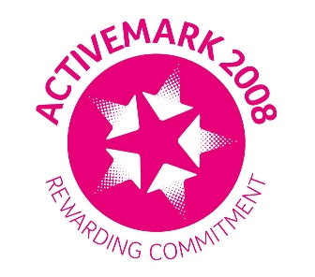 |  |  |  | 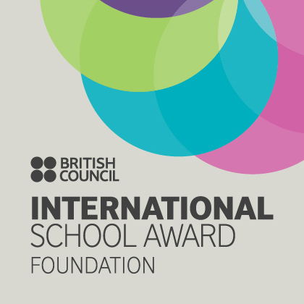

West Bretton Junior & Infant School

Newsletter

15.5.14

Welcome to another new starter this week – Hayden Rook - who joins Mrs Firth`s part-time children. We look forward to him becoming part of our school.

SATs

Our year 6 children have coped very well this week with their SATs which finish today. Thank you for your support at home in making sure children have been prepared with plenty of sleep and a good breakfast.

School Photographs

The photographer will be visiting school on Wednesday morning next week to take photographs of class groups. Proofs will be sent out as soon as they are available and photographs delivered in good time for our “leavers”.

Sportsdesk

A group of our year 2, 3 and 4 children enjoyed a cricket “taster” session yesterday after school when a representative from West Bretton Cricket Club came to school. There will be another session next Wednesday afternoon 3.30 – 4.30 p.m. If any other children from years 2, 3 and 4 are interested in joining the group please come along.

After school this evening we have a team of children from Mrs Scott`s class entering “The Cube” challenge at Horbury Academy. We wish our team the best of luck and will report on the result next week.

FOBS

As we mentioned last week, there will be a meeting in school next Wednesday at 3.30 p.m. for any parents willing to help out at the FOBS “Summer Fun Day” during the evening of July 11th. Please attend if you can – there is currently a very small committee and the members cannot run events without extra help. There will be a member of staff in school to supervise children whilst parents attend the meeting.

Visit to Wakefield Central Mosque

Years 5 and 6 are visiting Wakefield Central Mosque on Wednesday next week as part of their work on their topic “Why are there now over 50 mosques in Yorkshire” – a study of Islam and it`s beliefs and practices.

They will be back for lunch as usual. Would girls please bring a headscarf to cover their head. Thank you to those parents who have offered to help with transport.
Golden Book

Due to Year 6 SATs this week, we have had no whole school celebration assembly. Last week`s “Golden Book” children were:

Class 1 Eleanor Leighton and Grace Quinn
Class 2 Archie Robertshaw and Emily Clarke
Class 3 Bailey Clarke and Austin Atkinson
Class 4 Harry Wormstone and Lily Walsh

Well done to you all – we will have a double “Golden Book” report next week.

School Uniform

The majority of children have had a letter and order form this week asking if they would like to order uniform for next year. (Our leavers have not had the letter for obvious reasons!)

Please put your order and payment in the FOBS post box which is by the office door before the end of next week which is when the order will be sent in.

Parking

Despite our plea last week, some parents are still blocking the pavement on Bretton Lane with their cars. We have had a complaint from a resident that cars are also either completely or partially blocking their driveways. We have always had a good relationship with the village community – please don`t spoil this by parking inconsiderately.

And finally …………

Our very short half term is almost over already; we finish at our usual time next Friday, 23rd May and return to school on Tuesday 3rd June.

