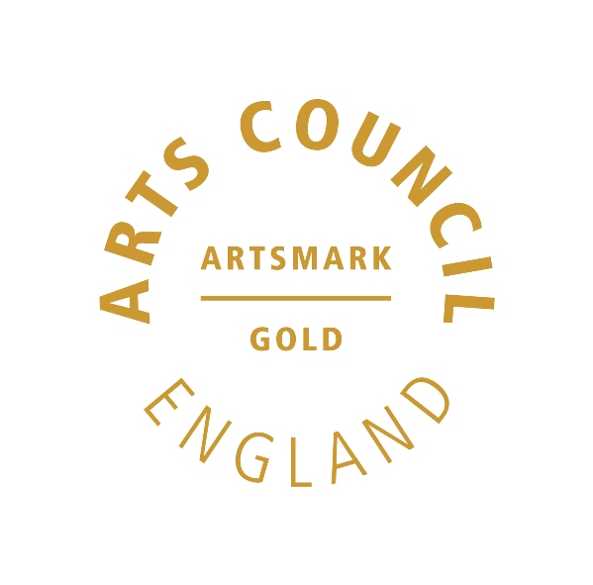 | 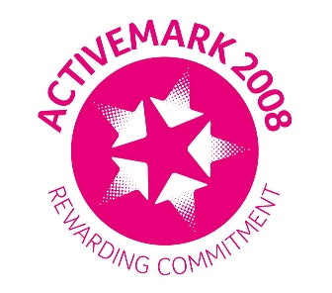 |  |  |  | 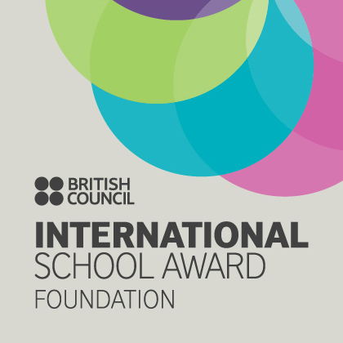

West Bretton Junior & Infant School

Newsletter

13.3.14

West Bretton Oscars

Several of our children took to the red carpet yesterday to receive their Oscar for particularly valuable contributions on World Book Day last week.

Staff identified special qualities such as working well with a partner, being patient, helping with younger children etc. Well done not only to those children who were presented with an Oscar, but to all our children who made it such a special day.

Congratulations!

We are very pleased to be able to let parents know that Mrs Firth, our Reception class teacher, is expecting her first baby in late July/early August. We are sure that you will join staff in offering her congratulations and best wishes.

After School Dance Club

We were very sorry earlier this week to have to contact parents to let them know that there would be no Dance Club for the rest of this half term, as the teacher is no longer able to run the class.

All parents have been given a full refund.

Total Sporting Events, who run the class for us have asked that we give their apologies. We hope to be able to run the Dance Club next half term, subject to a suitable instructor being found.

Toast for Africa

Ms Trueman will again be selling toast for 30p at morning break tomorrow. All the profits will go towards the trip to Lesotho next Spring.

Thank you to those parents who have sent in shoes for the shoe collection, another fundraiser for Africa. The box is at the end of the corridor outside the hall – it is rather full at the moment so please put any shoes in bags at the side until they are collected.

Golden Book

Congratulations to our “Golden Book” children this week:

Class 1 Cameron Burns and Sophie Fisher
Class 2 Willem Simpson and Sam Dodd
Class 3 Samuel Ollerton
Class 4 Lucy Care and Sam Lodge
Sportsdesk

Our netball team had a wonderful result at the tournament at Horbury Academy on Tuesday. They won three of their four games, putting them in second place. Their teamwork was absolutely brilliant and we are very proud of them – Sam Lodge, Olivia Hargill, Andrew McWilliams, Lucy Care, Edward Booth, Emily Fuller and Amelia Jones.

Book Fair

Our Book Fair got off to a good start yesterday. We shall be running it tonight, tomorrow and Monday after school. Thank you for supporting this event – the commission we receive enables us to buy books for school.

Sport Relief Day

Attached is a letter from our Student Council giving details of our Sport Relief Day next Friday. All the children are, as ever, very enthusiastic about this event and we are very grateful for the support we always receive from parents. Thank you.

And finally ………….

Would parents of children in years 3 and 4 who have not yet returned the slip for the “Eureka!” trip please do so this week.

