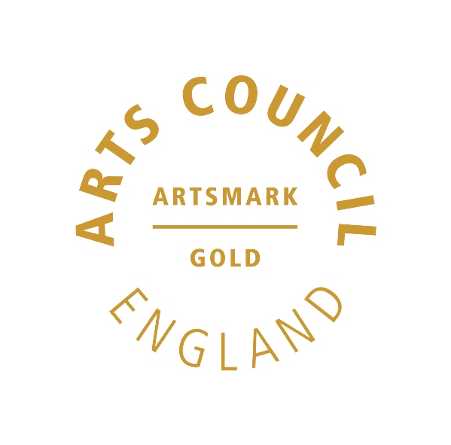 | 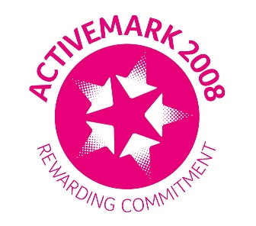 |  |  |  | 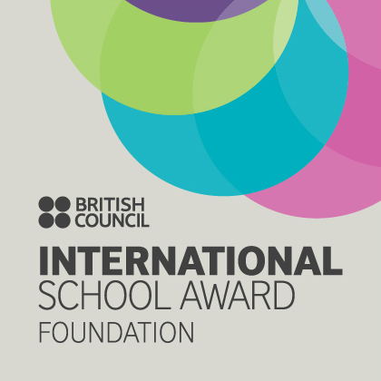

West Bretton Junior & Infant School

Newsletter

13.2.14

Visiting Artist Days

Sally Gillford from YSP spent two days in school this week with our KS2 children teaching them printmaking. The children found the process fascinating and thoroughly enjoyed printing tote bags and teatowels which will eventually be sold to raise money for our Africa Trip.

Friends of Bretton School

The next meeting of FOBS will be on Tuesday 25th February at 7.00 p.m. at Kath O`Donnell`s house. The agenda will include the Easter Disco, Race Night kit and the playground.

As always, FOBS welcomes any parent to their meetings, irrespective of whether they are members or not. If you wish to attend please ask at the school office for the address or see Kath (Luke and Jacob`s Mum in Class 2).

Golden Book

This week`s “Golden Book” children are:

Class 1 George Godley and Tilly Davitt
Class 2 James Gibson and Peter Maher
Class 3 Travis Joubert and Iona Burns
Class 4 Mia Stokes and Harry Wormstone

Well done to all of you!

ZooLab

Our Foundation Stage and KS1 children were introduced to all sorts of weird and wonderful creatures yesterday when they had a visit from “ZooLab”. Mrs Grindle very bravely held a millipede, and the children were introduced to a tarantula, a lizard, a gerbil and a snake!

Lunch Money

For parents wishing to pay for the full half term after the break, the amount will be £61.20 with the exception of year 5/6 children who will pay £59.40. This is to allow for their day out to Blue Planet on 28th February when they will require a packed lunch.

For parents paying weekly, please pay £7.20 for the first week and £9.00 thereafter. Please note that all lunch money should be paid on the first day of the half term or on each Monday morning, in a named envelope placed in the post box outside the office door. Cheques should be made payable to either WMDC or West Bretton Junior and Infant School.
Foundation Stage Assembly

Our Foundation Stage children will be delighted to see you at their assembly tomorrow morning shortly after 9.00 a.m.

Breakfast Club Questionnaire

Thank you to those parents who returned the Breakfast Club questionnaire. The responses were analysed and our Governing Body found that there would be insufficient support for an earlier start. Breakfast Club will therefore remain at an 8.00 a.m. start at a cost of £3.00.

Sportsdesk

We were very proud of our Year 5 and 6 children last week when we were able to send 2 teams to the “Wake up Shake up” competition at Horbury Academy. We were the only school in the pyramid to be able to send two teams. Our teams took 2nd and 4th places so very well done to Steven Taylor, Lily Walsh, Lucy Care, Mia Stokes, Lottie Wood, Amelia Garthwaite, Elli Clark, Freya White, Amelia Jones, Harry Wormstone, Isabelle Lidster and Olivia Hargill.

Our next sporting event is on Thursday 27th February when we will be entering a year 3 team into the Unihoc competition, again at Horbury Academy.

Africa Meeting

Those families who have put their names down for the Africa Trip please note that there is another meeting on Wednesday 26th February at 3.30 p.m.

Violin

Would Miss Ghent`s violinists please bring their instruments on the Wednesday of our first week next half term, instead of the Thursday.

And finally …………………

We hope that everyone enjoys the half term break. School is closed to pupils on 24th February, and we look forward to seeing the children on Tuesday 25th February.

