 | 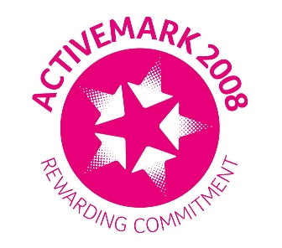 |  |  |  | 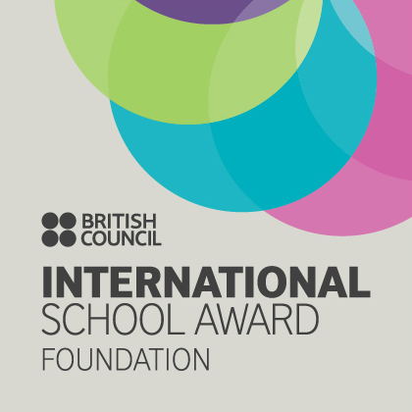

West Bretton Junior & Infant School

Newsletter

10.7.14

Fashion Show

Our Fashion Show on Monday was a huge success and raised £352. The children made a wonderful job of organising the event and had a lot of fun in the process.

Thank you very much to those parents and friends who supported us, and also to Miss Riley and Miss Bowser for the time and effort they put in during the weeks before the show.

There are some clothes still unsold – these are brand new, current Marks and Spencer items at half the retail price. If you are interested, please have a look through the clothing racks in the corridors.

There was a photographer from the Wakefield Express at the fashion show so keep an eye on the paper tomorrow or next week.

Play Area Quesionnaire

Kath O`Donnell, one of our parents and also a member of FOBS is in the process of applying for a lottery grant to update the play area. Earlier this week a questionnaire was circulated and we would really appreciate as many parents as possible completing the form as this will add weight to the application. Please return them as soon as you can via the FOBS post box.

If the grant application is successful it is unlikely that the full cost of the upgrade will be met. If any parents have contacts who may be willing to sponsor or make a small donation towards the cost, Kath would be delighted to hear from you!

End of Term Activities

It was lovely to see so many parents in school on Monday afternoon – the children love to share their work with you.

Next week we invite parents and friends in to school again. On Tuesday afternoon at 2.30 p.m. our Foundation Stage and KS1 children will be putting on their summer performance here in school. The following day at 2.15 p.m. it will be the turn of our KS2 children to entertain you.

Next Friday we invite you to our leaver`s assembly at 9.00 a.m. This is always a morning of mixed emotions as we say goodbye to our leavers and wish them well in the next step of their journey.

Family Fun Night

We are hoping for a fine evening tomorrow when FOBS have arranged the Family Fun Night from 6.30 – 9.00 p.m. It is still not too late to buy tickets, so please put your order in the FOBS letter box outside the office door.

Next Term

Although still a long time away we would like to remind parents of our return dates in September.
School will be closed to pupils on Monday and Tuesday 1st and 2nd September as these are staff INSET days.

On Wednesday 3rd September all children with the exception of full time Reception children will return to school. These children will return to school on Friday 5th September, as Reception staff will be carrying out home visits for our new starters on Wednesday and Thursday that week.

Bretton Village Fun Day

Unfortunately the Village Fun Day planned for 20th July has had to be cancelled as Bretton Cricket Club is no longer able to host the event. The organisers apologise to anyone who may have wanted to take advantage of the cricket coaching on that day.

It is hoped that an alternative fundraising event may be held later in the year, as the money raised was to pay for the village Christmas tree and lights.

School Lunches

Kingswood, who supply our school lunches have advised us of a price increase as from September when the cost of a meal will be £2.00 per day.

Parents of children up to the end of Year 2 from September will have already had a letter advising them that a government initiative means that they will not have to pay for school meals until children enter Year 3.

And finally …………..

Tomorrow evening is the last Multisports Club, there will be no club next week.

Please remember that we finish school for the summer break at 2.30 p.m. next Friday. There are some booklets in the corridors with ideas for outings during the break, together with vouchers.

